Created Repository in GitHub:
- https://github.com/BennettLandman/ES3890Spring2026
I’m using VSCode:
- https://code.visualstudio.com
Clone from GitHub: https://github.com/BennettLandman/ES3890Spring2026.git
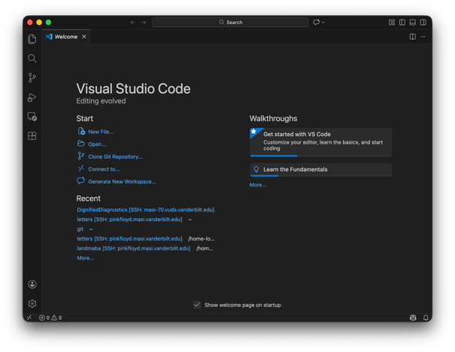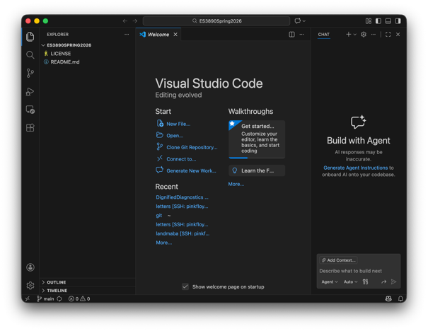
Create a folder for tutorials / HowTo (incuding my VibeVoice tutorial from earlier this term):
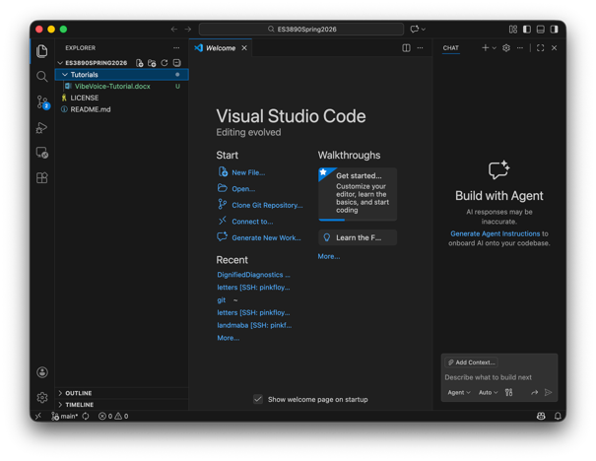
Add new files to GitHub:
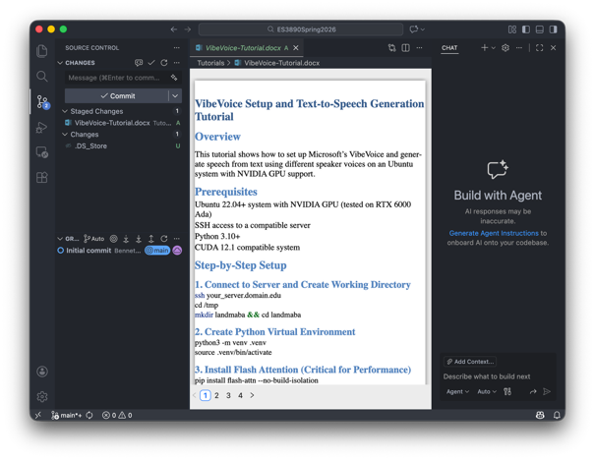
Finish setup of GitHub by setting my username and e-mail on the terminal:
(base) landmaba@FreeFall ~ % git config --global user.name "Bennett Landman"
(base) landmaba@FreeFall ~ % git config --global user.email "bennett.landman@vanderbilt.edu"
Note that “Commit” is local only. “Commit & Push” sends to GitHub.
We can now see the result on the GitHub website, BUT the file is binary and we have to download it.
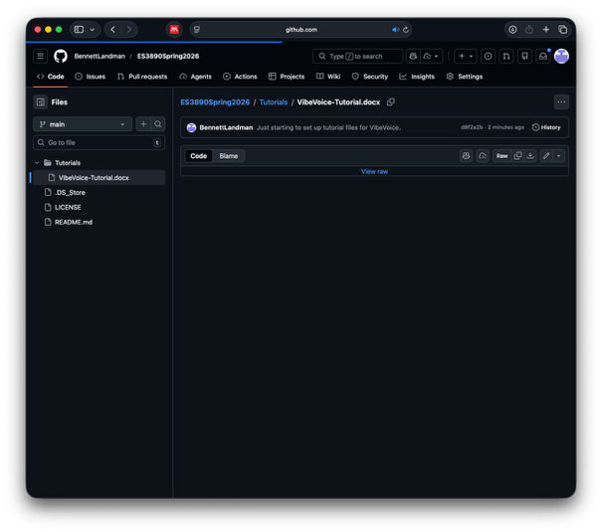
To convert to markdown, I use an LLM (but there are tons of ways).
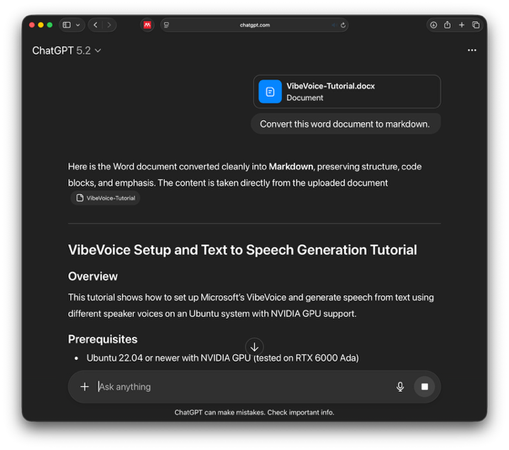
I then copy/paste into a new file in VSCode, save and commit/push:
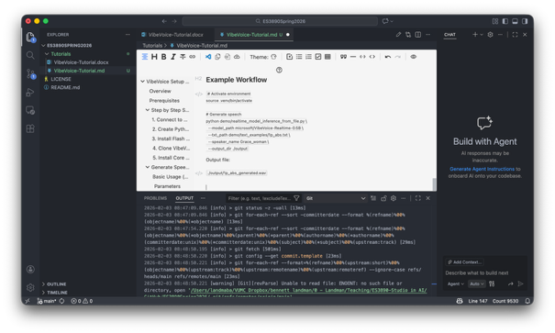
Poof! The tutorial is now nicely viewable on the GitHub website:
